Light Grapher Instructions for Use with the Albedo Detector Spinner:

Background

Light Grapher is a Flash applet developed through NASA that allows your webcam or built-in computer camera to act as a rudimentary light sensor to display graphically the brightness of reflected light off of a revolving target object. Objects of different color, shape, and texture reflect light differently.

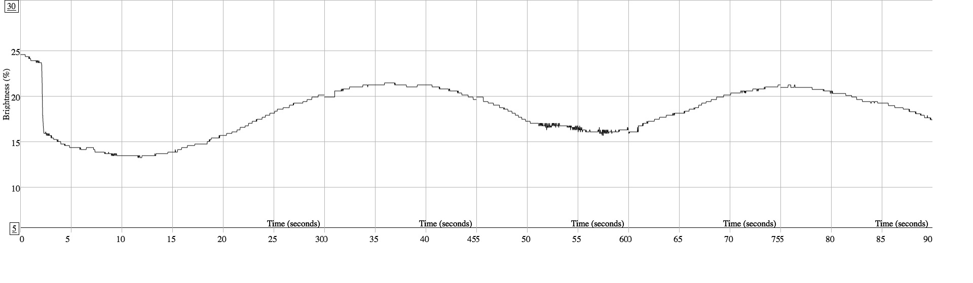
When a darker-colored object or an object that does not reflect light well is positioned in front of the light source, the brightness drops and a dip in the amount of light collected by the camera is depicted as a light curve on a graph.

The software receives real-time data from the external webcam or internal computer camera. The software may be run either directly from the internet page or can be downloaded and run locally in your browser.

The instructions below were modified from the Light Grapher website (link below) for an experiment to graph the brightening and dimming of light due to the passage of an object in front of a light source simulating exoplanet detection. The Light Grapher software for our purposes uses a technique adapted for the Albedo Detector Spinner activity. The Light Grapher will be used to sense the reflected brightness, called albedo, from objects of different color, shape, and texture. This is a technique used to simulate the detection and tracking of asteroids and orbital space debris.

Light Grapher Operation Instructions:

1. Construct or access an Albedo Detector Spinner Instructions on how to make the
Albedo Detector Spinner can be found on the EIS Academy (link below) Test and adjust the revolution period of your spinner so that it revolves one or two times during a set time period. The Light Grapher exposure time default is 30 seconds, but it can be customized to your spinner by modifying the "Capture Data" command. An alternative to using the Albedo Detector Spinner is to simply hold the object in your hand and rotate it 360o at an even rate. This method works, however, care needs to be taken to prevent vibration due to an unsteady hand.

2. Secure the target object on the spinner. Strong tape may work well or your spinner may have some exposed screws that you can use to secure your target object. You do not want the target object to wobble when the spinner is rotating.

3. Position a dark surface behind the
Suggested Configuration
Spinner
Dark Screen
Camera
Light

spinner with the target on it. A dark
surface will reduce ‘noise’ and provide
cleaner data.

4. Position a light on your target so that it
is reflected towards the camera. A light
source at about 1 meter away works well.
A light bulb or a cell phone/mobile
device light app is also a good light source.
If you choose a very dark environment, you might need to increase the exposure time of the
camera and/or slow down the rotation
time of your target (or spinner).

5. Start the Light Grapher software to allow the brightness data to come in through your camera.

6. Aim the camera at your target object by centering the targeting circle of the Light Grapher software on the part of the object that you would like the albedo measurements taken. You can set the target circle by using the slider located on the right of the Light Grapher screen.

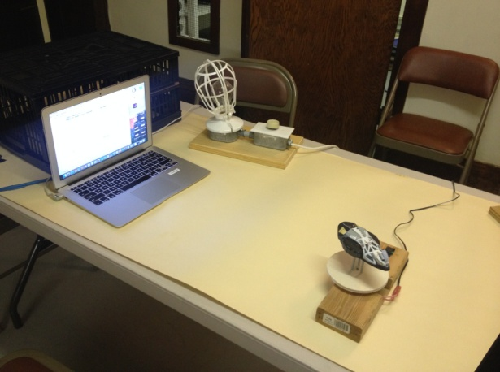
7. Test the target object on your spinner using the targeting circle and adjust the target object as necessary. The default time is 30 seconds.

8. Click the "Capture Data" button as your target object is moving around on its axis.

9. You may wish to adjust the vertical scale by clicking the 'Autoscale' or manually entering the maximum and minimum % values at the bottom and top of the y-axis.

10. The 'Pause' button can be used and then 'Resume' at anytime in the 'Data Capture.'

11. Data can be saved for any trial as a .png graphics file and then opened in a graphics program.

Resources:

EIS Academy
https://www.eisacademy.org

Light Grapher Website
The information on this page is adapted from Julia Kahmann-Robinson and Marjorie Chan’s Light Grapher activity found at:
https://kepler.nasa.gov/education/ModelsandSimulations/lightgrapher/
Suggested Configuration
Spinner
Dark Screen
Camera
Light

Suggested Configuration
Spinner
Dark Screen
Camera
Light

