Vectors and Forces
In this lesson, we will go over the use of vectors to solve problems using force.
Torque or Moment of a Force
Torque is a measure of how much force is acting on an object that causes the object to rotate. As force is thought of as a push or pull, torque can be considered as a twist to an object. The object rotates about a centre of rotation, which will be denoted O. The force acting on the object will be denoted $\vec{F}$ (in Newton), and the distance from the centre of rotation to where the force acts is called the moment arm and will be denoted by $\vec{r}$ (in metres).

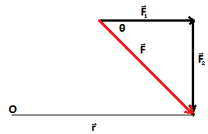
Note, that in the diagram we have vectors $\vec{F}$₁ and $\vec{F}$₂. This is to remind us that $\vec{F}$ is the composition of two vectors. Also, remember that vectors have magnitude and direction, hence the arrowheads.
The equation for torque is given by:
= $\vec{r}$x$\vec{F}$
or the cross product of the moment arm and the force acting on the object
Since torque uses the cross product equation, it can be rewritten as:
II=I$\vec{r}$I I$\vec{F}$I sinθ
Where θ is the angle between the two vectors.
Something to note from the diagram is that θ is located between the vectors $\vec{F}$₁ and $\vec{F}$. From corresponding angles, we know that this θ and the angle between vectors $\vec{r}$ and $\vec{F}$ are the same. Therefore, the diagram can be drawn as:
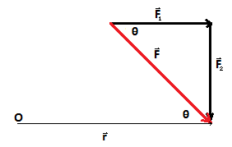
Example
Determine the torque of the system given the information below.
$\vec{r}$ = 30cm = 0.3m
θ= 30⁰
$\vec{F}$= 50N
With the given information, we know which equation to use to determine the torque.
II=I$\vec{r}$I I$\vec{F}$I sinθ
II= (0.3)(50)sin(30)
II=7.5Nm (or Torque units)
Work done by a Force on an Object
While work can have many definitions (as you are reading this, you are doing work too!), we will use the definition of work as taking place when a force acts upon an object to cause a displacement. That means, work is when a force acts to cause an object to be displaced.
Note: For these calculations, we will be considering a frictionless system. With a frictionless system, we do not need to consider forces moving against the pushing force.
To calculate the work done on an object, three things are needed. Those three things are the force $\vec{F}$ (in Newton), the displacement $\vec{d}$ (in m), and the angle between the force and the displacement.

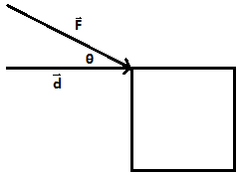
To calculate the work done by a force, the equation we use is:
W= $\vec{F}$•$\vec{d}$
Or
W= I$\vec{F}$I I$\vec{d}$I cosθ
Example
Determine the work done when a 100N upward force is applied to lift an object a distance of 5m.
Since the force was applied vertically and the object was lifted, the angle between the force and the displacement is 0.
W= I$\vec{F}$I I$\vec{d}$I cosθ
W= (100)(5)cos(0)
W= (100)(5)(1)
W= 500Nm
Practice Problems
For each of the following questions, please draw a diagram to accompany your solution.
- Calculate the torque of a system with an applied force of 500N, moment arm of 50cm and an angle of 60⁰.
- Determine the torque of a system with an applied force of 300N, moment arm of 10M and an angle of 45⁰.
- With a torque of 700Nm, and an applied force of 10N at an angle of 30⁰, what is the length of the moment arm?
- Calculate the work done when a 200N force is applied at a 60⁰ angle, with a horizontal displacement of 10m.
- At what angle is the forced applied if 433Nm of work is done when a force of 100N is applied, and the resulting displacement is 5m.
- Determine the displacement of an object if 735Nm of work is done when a force of 147N is applied horizontally.

