What is a Vector?
Vectors have various applications in the fields of both math and physics. How does a spacecraft stay in orbit? Why does wind play such a big role in sports like golf? How do billiard players make such interesting shots? This is part due to the use of vectors.
So what is a vector?
A vector is a quantity that has both a magnitude and direction. Force and velocity are generally good examples of vectors as both have a magnitude and a direction associated with them.
For example 5m/s by itself is not a vector, nor is moving east a vector. However, 5m/s moving east is a vector. Another example of a vector would be a force of 3 Newton being applied in a westward direction.
Graphically, vectors are represented by directed line segments (lines with arrow heads). The length of the vector indicates its magnitude and the direction of the line segment indicates its direction. While simple to understand, this presents a problem as the vector does not provide any additional information such as its location on the graphing plane. Thus, a single vector can have many representations.
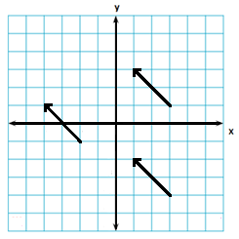
In the above sketch, all of the line segments have the same magnitude and direction. Thus, these line segments all represent the same vector and are called representations of the vector. Note however, that all of the line segments are in different locations.
The notation of vectors is based on the rise and run. In the line segments above, they all begin at a specific point, then moves 2 units left and 2 units up to the end of the segment. This notation used for the vector is $\vec{v}$=<-2, 2>. Remember that the notation for vectors is different from those of general points on the place (x, y). This also applies on the three-dimensional space.
In general terms, to determine the notation of a vector, two points need to be identified of any directed line segment. The start of the line segment A= (x, y) and the end B= (x+ a, y+ a₂). Thus the vector can be generalized as $\vec{v}$= <a₁, a₂>, where a₁ and a₂ are the differences between the x and y-values of points A and B respectively. This also applies to vectors in the three-dimensional space. A vector in the three-dimensional plane $\vec{v}$= <a₁, a₂, a₃> is a directed line segment from the point A= (x, y, z) to B= (x+ a₁, y+ a₂, z+ a₃).
Moving forward, vectors should not be considered strictly in three or two-dimensional space. Vectors exist in general n-dimensional spaces where n can be any positive whole number. Thus, the general notation for n-dimensional vector is $\vec{v}$= <a₁, a₂, a₃, … a_{n}>
Now that you have been introduced to vectors, let’s move on to the basics.

Basics of vectors
When given a vector $\vec{v}$= <a₁, a₂, a₃> the magnitude of the vector can be calculated using the following formula.
II$\vec{v}$II= √ a²+ a₂² +a₃²
A few facts regarding magnitudes:
- If II$\vec{v}$II= 0, $\vec{v}$= <0, 0, 0>. This should make sense as the only way to have a 0 result is to have all components (a₁², a₂² and a₃²) equal 0. Zero vectors are denoted $\vec{0}$
- Any vector with a magnitude of 1, or II$\vec{v}$II= 1 is called a unit vector
There are 3 unit vectors in the three-dimensional space and two in the two-dimensional space (known as standard base vectors).
In general, these unit vectors are known as$\vec{i}$, $\vec{j}$ and $\vec{k}$
$\vec{i}$ = <1, 0, 0> or = <1, 0>
$\vec{j}$= <0, 1, 0> or = <0, 1>
$\vec{k}$= <0, 0, 1>
**Note- These vectors are specific vectors and are not interchangeable

Exercises
- Draw three possible vectors for <-3, 5> and <2, -3>
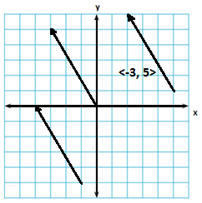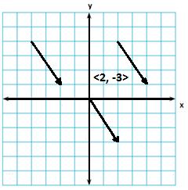

- Give the vector for the following:
- The vector from (-3, 6) to (-4, 9) - <-1, 3>
- The vector from (9, 3, 4) to (2, 5, 1) - <-7, 2, -3>
- The vector from (-4, 5, -6) to (2, -4, 7) - <6, -9, 13>

- Complete the chart below.
Vector | Magnitude | Is it a Unit Vector? | Is it a Zero Vector?
<-14, -2, 3> | 14.5 | No | No
<1, 3, 5> | 5.9 | No | No
<3, 16, -2> | 16.4 | No | No
<1,0,0> | 1 | Yes | No
<0, 0, 0> | 0 | No | Yes
The vector from (0, -7, 1) to (3, -4, 2) | <3, 3, 1>, 4.4 | No | No
The vector from (-4, -7, -6) to(5, 9 -8) | <9, 16, -2>, 18.5 | No | No

