Orbits
Now that there is some familiarity with gravity and space, let’s move onto orbits. Orbits are defined as the speed (more specifically the kinetic energy) of the orbiting object. The laws of orbiting bodies was developed by Johannes Kepler, who based these laws around the detailed observations made in the 1600’s by Tycho Brahe. Kepler’s laws state the following:
- Planets move in elliptical orbits, with the Sun at one focus of the ellipse or orbits are elliptical with the greater mass at one end of the foci
- An imaginary line between the Sun and a planet sweeps out equal areas in equal time intervals. This law dictates the speed at which a planet will move while orbiting the Sun. A planet will move fastest when it is closest to the Sun and slowest when furthest from the Sun.
- The quotient of the square of the period of a planet’s revolution around the Sun and the cube of the average distance from the Sun is constant and the same for all planets. This can also be explained using formulas:
T²= K or T_{A}²= T_{B}² T- period of a planet’s revolution around the Sun
r³ r_{A}³ r_{B}³ r- average distance from the sun
A and B are two objects in orbit with one another
K- is a constant
The minimum tangential speed required for an object to have in order to enter a circular orbit around the earth is 8km/s. If a satellite has a speed any slower than 8km/s, it would eventually crash into the Earth’s surface. Most orbiting objects have a speed greater than 8km/s, thus resulting in an elliptical orbit with the Earth at one focus of the ellipse (assuming the object is orbiting Earth). The point at which the two objects are the closest to each other in their orbit is called the perigee, the point where they are the farthest is called the apogee.
Circular Orbits
Circular moments are the result of centripetal force (the force that makes an object move along a curved path) being equal to gravitational force. This can be expressed as a function, knowing the equations for both forces.
Centripetal force is calculated using the formula: F_{cent}= mv²
r
Where m, v and r represent mass, velocity and radius of the curved path respectively.
From the gravity lesson, we learned that gravitation force between two objects (which is essential in orbits) is calculated using: F_{grav}= G* m₁*m₂
r²
Where G is the universal gravitational constant (6.67 x 10⁻¹¹ N*m²/kg² (or m³/kg*s²), m₁ and m₂ are the masses of the two objects and r is the distance between the objects.
Note- In the previous lesson, we used d to denote the distance between objects. Generally, r is used to represent the distance between the two objects.
Therefore, circular orbits are the result of:
F_{cent}= F_{grav}
mv²= G* m₁*m₂
r r²
Gravity and Satellites
Satellites in space have their own orbits around the Earth. As they orbit, they are also affected by the pull of gravity. Without their own motion, they would fall back into Earth and burn up in the atmosphere. Therefore, the motion of the satellite moving around the Earth has in upwards force equivalent to the downwards pull. Also, for any given orbit there exists a velocity at which gravity and the centrifugal force balance each other out, thus resulting in a stable orbit in which the satellite neither gains nor loses height.
Generally, satellites travel in what is called low Earth orbits. This orbit is high enough that atmospheric drag will not pull the satellite back down but also low enough that they just pass over mountains.
Why is this so?
We know that the lower a satellite’s orbit, the stronger the gravitational pull and the faster it must travel to counteract the force. The further a satellite is, the lower the gravitational field and the slower the satellite must travel.
Low Earth orbits are generally used for things that we want to visit such as the Hubble Space Telescope or International Space Station (ISS). Because of the short travel time maintenance of the satellites (installing new parts, repairs or inspections) can be easily done. It is also the only way we can have astronauts go into space, conduct experiments and return in a relatively short amount of time.
The disadvantages of low earth orbits are atmospheric drag and the speed at which the satellite moves around the Earth. Atmospheric drag is the decrease in velocity due to the atmosphere. While there isn’t enough air to breathe, there is enough to drag a satellite or other object. Eventually the satellite would slow down and gravity would pull it down towards the Earth. Now recall that the lower a satellite is, the faster it needs to move in order to maintain its orbit. For example, at an altitude of 22000 miles a satellite would need to move at a velocity just less than 7000mph just to maintain an orbit of 24hrs. This means that a satellite would not spend a lot of time over a certain part of Earth. What if we need a satellite to stay over a certain part of Earth? How would a weather satellite for North America be useful if it spent more time in other parts of the world?
Instead of circular orbits, weather satellites move in a highly elliptical orbits or geosynchronous orbits.
According to Kepler’s second law, the closer a satellite is to Earth, the faster it moves and the further the slower it moves. Using an elliptical orbit, the satellite would spend most of its time near the apogee where it moves slowly and rests when it is in the perigee (which would be quick). Thus, a weather satellite would be able to spend more time over a certain area and take reports. In order for weather reports to still occur while the satellite is in its perigee, two satellites would be used. The second having a similar orbit but timed so it is in its apogee while the first one is in perigee.
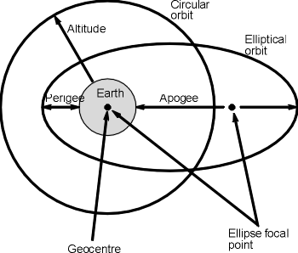
http://www.radio-electronics.com/info/satellite/satellite-orbits/satellites-orbit-definitions.php
Note- Ellipse focal points are two fixed points on the interior of an ellipse spaced equally from the center. These two points are always along the longer side of the ellipse.
Geosynchronous orbits are orbits that have the same orbital period as the Earth. If the satellite was moving at the same speed as the Earth, the satellite would be constantly over a certain area of land. To maintain this period, a satellite needs to be a certain distance away from the Earth in order to have enough velocity. Using Kepler’s third law we can determine how far the satellite must be to achieve the same period as the Earth, which was approximated to 36,000km. This is larger than a low Earth orbit, but only requires a single satellite for uses such as weather reports.

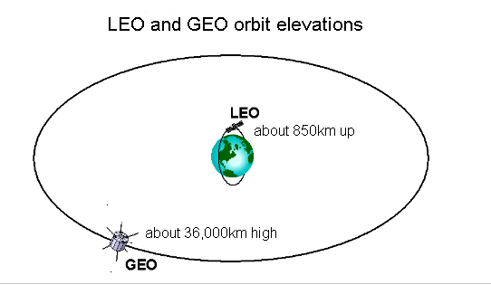
http://pics-about-space.com/low-earth-orbit-satellite?p=4#

References:
Iowa State University. (n.d.). Types of Orbits. Retrieved March 26, 2016, from
http://www.polaris.iastate.edu/EveningStar/Unit4/unit4_sub3.htm

