Modelling Equations in 3D
In previous journals, the concept of graphing lines was introduced. In this activity, this concept will be reviewed and expanded on.
Modelling Lines on the Three-dimensional Plane
As mentioned in “Introduction to Graphing in Three-dimensions”, a line in two-dimensions would appear as a plane in three-dimensions. In this section, how to graph these lines in three-dimensions will be reviewed.
Graphs of Coordinate Planes:
For equations in the form x=a, y=b, or z= c where a, b, and c are any number in the real number system (or a, b, c ∈ ℝ) the graph would be in the form of a square plane.

Example 1- Graph x=3, y=3 and z=3
For the graph x=3, in the 3-D coordinate system, this is represented by the set of points (3, y, z) where y and z can be any value. Thus, a square plane is formed that is parallel to the yz-plane and passes through the x-axis at x=3
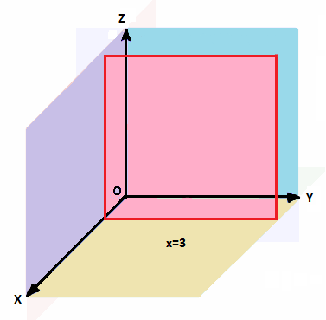

For the graph y= 3, it is the square plane that is parallel to the xz-plane and passes through the y-axis at y=3.
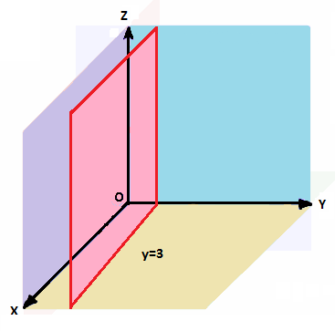
For the graph z= 3, it is the square plane that is parallel to the xy-plane and passes through the z-axis at z=3.
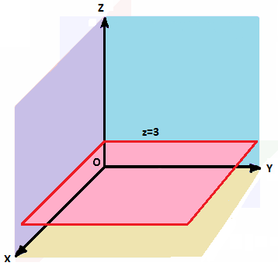

Graphs of lines in the form y=mx+ b:
Recall that lines in the form y=mx+ b have a slope of m and a y-intercept of b in the 2-D plane. For example, the line y= 3x- 2 has a slope of 3 and a y-intercept of -2. On the 2-D plane, the graph would look like the following line.
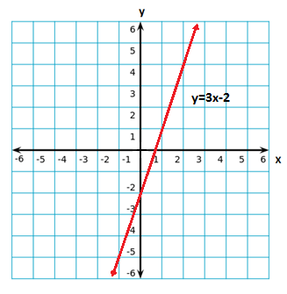
For the 3-D representation of this graph, the value of z has not been specified. Therefore, any value of z will get a copy of this line. The graph is then a vertical plane that lies over the line y= 3x-2.
**Note**- Despite being represented as a square of certain size, the plane extends infinitely in all directions.
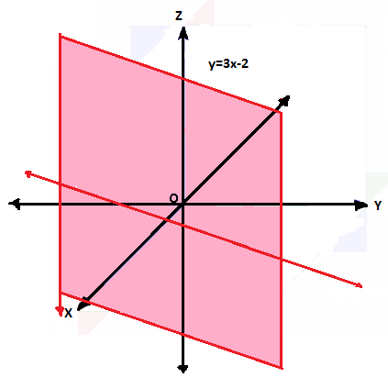

This logic can also be applied to equations such as x²+ y²= r², where r∈ ℝ.
Let’s look at the equation x²+ y²= 9.
On the 2-D plane, the graph of this equation would be a circle with radius 3 (the square root of 9). It is noted that this equation does not define a z-value. Thus, if this equation was graphed onto the 3-D plane, it would appear as a cylinder with a radius of 3 centered on the z-axis.

Graphing linear equations in 3-D:
Finally, let’s review graphing linear equations that have defined x, y and z values.

Example- Graph 6x+2y-4z= 12
To graph this equation, the x, y and z intercepts are determined.
Recall that the intercepts are the following:
x-intercept: (a, 0, 0) where a, b, c ∈ ℝ
y-intercept: (0, b, 0)
z-intercept: (0, 0, c)
To determine the intercepts, zeros are substituted where appropriate and the equation is solved for a, b, or c.
Solving for the x-intercept:
To find the x-intercept, we substitute zeros and a in exchange for x, y, and z.
6x+ 2y- 4z= 12
6a+ 2(0) - 4(0) = 12 Substitute for x, y, and z
6a+ 0- 0= 12
6a= -12
a= 2 Therefore, the x-intercept is located at (2, 0, 0)
Using the same method to find the y- and z-intercept, we find that the y-intercept is (0, 6, 0) and the z-intercept is (0, 0, -3).
Now that the intercepts have been found, the equation can be graphed using those points.
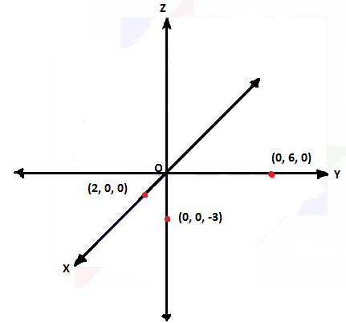
First the intercepts are plotted onto the coordinate plane. Next, the points are connected with lines to form a triangular plane. This plane represents the set of points that adhere to the linear equation.
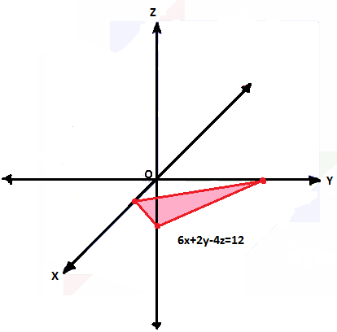
**Note**- The plane that is formed extends infinitely on all sides, but is drawn as a triangle.

Fill out the chart below. Predict the appearance(s) of the graph(s) before graphing the equation. When showing your work, write the rational in drawing the graph.
Equation | Appearance Prediction | Work | Graph
Y= 4  Z= -5 | Y= 4 will be a square vertical plane parallel to the xz-plane  Z= -5 will be a horizontal square plane parallel to the xy-plane | Y= 4 is a plane parallel to the xz-plane and passing through y= 4  Z= -5 is a plane parallel to the xy-plane and passing through z=-5
Y= 2x-6 | Y= 2x-6 will be a vertical plane that passes through the line y=2x-6 | From y= 2x-6 the line has a y-intercept of -6 and a slope of 2. The graph of this line is
X²+y²= 16 | The equation will produce a cylinder centered around the z-axis | The radius of the circle is the square root of 16, which is 4. Since there are no restrictions on the value of z, z can be any value. Thus the cylinder extends infinitely.
( y= x+1) | The vertical plane passing through the points (2,3,0) and (-5,-4,0) | Since the plane is vertical, there are no restrictions on the value of z (z can be disregarded during the calculations). The plane passes through 2 points, thus we can use those points to find the equation of the line the plane passes through.  m= y₂-y₁  x₂-x₁  m= 3- (-4)  2- (-5)  m= 3+4 = 7 = 1  2+5 7  y= mx+b  y= x+b  3= 2+b The equation of the  b= 3-2= 1 line is y=x+1 | In 2-D:  In 3-D:

(Continued on the next page) z

Equation | Appearance Prediction | Work | Graph
(x²+y²= 4) | The cylinder that is centered on the z-axis with a radius of 2. | It is given that the appearance of the graph is a cylinder centered on the z-axis. This means that the equation follows the form x²+y²=r². The radius of the cylinder is 2 and thus the equation is  x²+y²=r²  x²+y²=(2)²  x²+y²=4
2x+5y-4z= -20 | The graph will look like a triangular plane pointed upwards | The intercepts of the function are:  (-10, 0, 0)  (0, -4, 0)  (0, 0, 5)
_x+ _y+ _z= 24  (-4x+6y-8z=24) | The graph will look like a triangular plane pointed downwards | The graph has intercepts at (-6, 0, 0), (0, 4, 0) and (0, 0, -3).  Using those intercepts, we can find a, b and c.  Ax+by+cz= 24 (sub a point in)  a(-6)+b(0)+c(0)=24  -6a+0+0= 24  -6a= 24  a= -4  Repeat this method to find b and c  B=6 and c= -8
Z= -3x+3y-9  2 | The graph will look like a triangular plane pointed downwards | The intercepts of the function are:  (-6, 0, 0)  (0, 3, 0)  (0, 0, -9)

