Free-Body Diagrams
When working through force problems, a helpful way to visualize the situation is through a free-body diagram. In these diagrams, all the forces acting on an object are represented using arrows that signify the direction and magnitude of the force. The longer the arrow, the greater the magnitude. The object is represented by a square.
Recall Newton’s third law, which states that for every action there is an equal and opposite reaction. In a free-body diagram, there will be arrows in multiple directions to signify the actions and reactions. In fact, the only rule in a free-body diagram is that all forces that exist for that object in the given situation must be drawn. Thus, it is important to know the various types of forces.
Let’s look at an object at rest.
When an object is at rest, there are two possible free-body diagrams (FBD) that can be drawn. In the first scenario, the only forces acting on the object are the force of gravity (which acts on all objects on Earth), and the normal force (which is the equal and opposite reaction to gravity). In this FBD, there would be an arrow pointing downwards and one pointing upwards. Both would be the same size to indicate the same magnitude of force (equal and opposite forces), thus cancelling each other out.
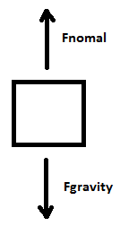
Similar to the first scenario, the second one has forces cancelling each other out. However, in this scenario there will be a force acting to the right. Without a reaction force, the object would no longer be at rest. To keep the object at rest, there must be a reaction force with the same magnitude of force but acting in the opposite direction.
Let’s say a force of 3.3N is acting on an object in the right direction. To keep the object at rest, we need a force of 3.3N acting in the left direction. If the force is less than 3.3N, the object moves to the right; if greater than 3.3N the object moves to the left.
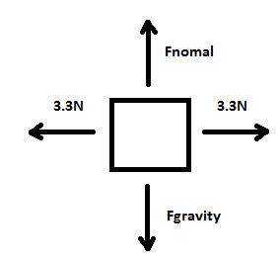
As an object moves across a surface, the force that often opposes it is the force of friction. This force is exerted by the surface itself and results from the two surfaces (the object and the surface) being pressed together, causing intermolecular attractive forces between the molecules of the surfaces. The two types of frictional force are sliding and static friction. Sliding friction is due to an object sliding across a surface (e.g.: a book being pushed across a desk). Static friction is the friction that exists between a stationary object and the surface on which it’s resting. Static friction force is the force that can oppose motion. For example if you are pushing a box that is not moving, the force of static friction is the force that keeps the box in place. Friction in detail will be discussed in the future.
For objects in free fall the only two forces acting on the object are gravity and air resistance. If it was a projectile at the peak of its arc (and neglecting air resistance), the only force acting on it is gravity.
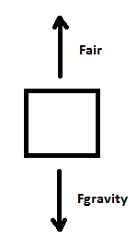
Object in free fall
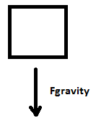
Projectile at the peak of its arc

Practice Problems.
Draw the appropriate free-body diagram for the given scenario.
- A box at rest. No additional force is applied.

- A box with an applied force of 3.5N

- A box at rest. If the applied force of 2.6N is increased, the box would move.

- A ball falling from a tree.

- Someone wearing a backpack.

- Draw your own diagram and describe the scenario.

