Gravity
Everyone is familiar with the idea of gravity. When an apple falls from a tree, when you knock a glass from a table, or throwing a ball up in the air and watching it fall back down. Gravity is an important force in our lives, and we’ll go into details about the effects of gravity in our lives.
Gravity is responsible for the idea that ‘What goes up, must come down”. When we jump into the air, the force of gravity (F_{grav}) slows us down before pulling us down towards the Earth. When you throw a ball high into the air, it eventually slows down before speeding up and falling to the ground. It can be said that the force of gravity causes this acceleration known as acceleration of gravity (g). Acceleration of gravity is defined as the acceleration experienced by an object when the only force acting upon it is the force of gravity. On and near the Earth’s surface, the value for the acceleration of gravity is approximately 9.81m/s² and this is the same value for all objects regardless of their mass.
The force of gravity acting on an object can be calculated using a simple formula.
F_{grav} = mg
Where m is the mass of the object and g is the acceleration of gravity.
Example- Calculate the force of gravity acting on a 47kg box.
We know that m= 47kg and g= 9.81m/s² so we can substitute these values into our equation.
F_{grav}=mg
F_{grav}= (47kg)(9.81m/s²)
F_{grav}= 461.07N

Gravity and Space
One may think that gravity has no role in space, especially when there are countless videos of astronauts experiencing weightlessness. Gravity plays a huge role in what keeps the planets in their current position.
Recall the Law of Universal Gravitation- Between any two objects in space, there is a force of attraction proportional to the product of the masses of the objects and inversely proportional to the distance of them squared.
This law was utilized by Newton to explain the orbits of the planets. To understand this law, we look at Newton’s thought experiment.
Suppose a cannon is fired horizontally from a high mountain. Eventually, the projectile will fall to Earth because of the gravitation force directed towards the centre of the Earth and the acceleration of gravity. As the velocity of the cannon is increased, the projectile will travel further and further before falling to the Earth. Newton reasoned that with the right velocity from the cannon, the projectile would travel completely around the Earth, always falling in the gravitational field but never reaching the Earth as it is curving away at the same rate that the projectile falls. This would imply that the projectile has been put into orbit around the Earth.
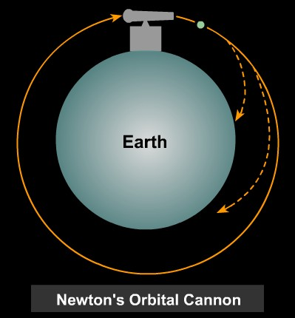
(http://csep10.phys.utk.edu/astr161/lect/history/newtongrav.html)
Newton used this logic to explain the moon’s orbit around the Earth: The moon continuously ‘fell’ in its path around the Earth due to the acceleration of gravity thus producing its orbit. Extending it further, Newtown came to the conclusion that any two objects in the Universe exert a gravitation attraction on each other.
The law of Universal Gravitation provides us with the following relationship:
F_{grav} $∝$ m₁ *m₂
r²
Which states that the force of gravity between two objects is proportional to the masses of the interacting objects divided by the distance between the centres of the objects squared (r). From this relationship we see that if the mass of an object is increased, the force between the two objects is increased. If the distance between the two objects is decreased, the force between them is as well.
The effects of mass and distance with regards to the force of gravity is best summarised by the following image:
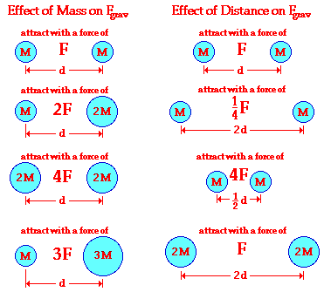
(http://www.physicsclassroom.com/class/circles/Lesson-3/Newton-s-Law-of-Universal-Gravitation)
The law of universal gravitation can also be expressed as an equation however, the difference between the proportionality and the equation is the introduction of the constant G (the universal gravitational constant). The equation is:
F_{grav} = G* m₁ *m₂
r²
Where the universal gravitational constant is G= 6.67 x 10⁻¹¹ N*m²/kg² (or m³/kg*s²)
Example:
Calculate the gravitational force between the Earth and the Moon.
The mass of the Earth and the Moon are 5.9736 x 10²⁴ kg and 7.349 x 10²² kg respectively.
The distance between the two is determined to be 3.844 x 10⁸ m.
Knowing this information, we can use the formula to determine the gravitational force.
F_{grav}= G* m₁ *m₂/r²
F_{grav}= (6.67 x 10⁻¹¹ N*m²/kg²)*( 5.9736 x 10²⁴ kg)*( 7.349 x 10²² kg)/( 3.844 x 10⁸ m)²
F_{grav}= (2.95x 10³⁷)/( 3.844 x 10⁸ m)²
F_{grav}= (2.928x 10³⁷ N*m²)/( 1.478 x 10¹⁷ m²)
F_{grav}= 1.982x 10²⁰ N
Therefore, the force of gravity between the Earth and the Moon is 1.982x 10²⁰ N.

Practice Problems
- Use the simulation linked on the activity page (https://phet.colorado.edu/sims/html/gravity-force-lab/latest/gravity-force-lab_en.html) to complete the following questions.
a) Set the mass of the two objects at 10kg each and place them 2m away from each other. Record the force acting on the objects. – F= 1652N
b) Increase the mass of ONE of the objects to 20kg, with no change in the distance between the objects. What is the new force? What is the relationship between this and the previous force of gravity? - F= 3304N, which is double the previous force of gravity.
c) Increase the mass of both objects to 20kg, with no change in distance between the objects. What is the new force? What is the relationship between this and the force of gravity in a)? – F= 6608N. This is four times the force of gravity in part a).
d) Predict the force of gravity if one object has a mass of 10kg and the other has a mass of 30kg (with no change in distance between the objects). – F= 4956N
e) Reset the mass of the objects to 10kg each and record the force between the objects. What is the force between the objects when they are 4m apart? 1m apart? What is the relationship between the new force and the original force? Complete the chart. What conclusions can you make?
Distance Between Objects | F_{grav} | Relationship between distance | Relationship between original F_{grav}
2m | 1652N | - | -
4m | 413N | Double the distance | ¼ the original force
1m | 6608N | ½ the distance | 4 times the original force
The closer the object, the stronger the force, the farther the weaker. The strength is based on a factor of 2 (which should be expected according to the proportionality).
- Complete the chart below:
Object 1 | Mass 1 | Object 2 | Mass 2 | Distance | F_{grav}
Earth | 5.9736 x 10²⁴ kg | Human | 70kg | 6.380 x 10⁶ m | 685N
Earth | 5.9736 x 10²⁴ kg | Mars | 6.39 x 10²³ kg | 2.250 x 10¹¹ m | 5.029x 10¹⁵ N
Moon | 7.349 x 10²² kg | Sun | 1.989 x 10³⁰ kg | 1.470 x 10¹¹ m | 4.512x 10²⁰ N
Moon | 7.349 x 10²² kg | Mars | 6.39 x 10²³ kg | 5.000 x 10⁷ m | 1.253x 10²¹ N
Mars | 6.39 x 10²³ kg | Sun | 1.989 x 10³⁰ kg | 2.279 x 10¹¹m | 1.632x 10²¹ N
Sun | 1.989 x 10³⁰ kg | Earth | 5.9736 x 10²⁴ kg | 1.496 x 10¹¹ m | 3.541x 10²² N

