Introduction to graphing in 3D
Similar to graphing in 2D, graphing in 3D has its own notations and coordinate system. Recall that the 1D coordinate system is denoted by and the 2D coordinate system is denoted by and has coordinates (x, y). For the 3D coordinate system, it is often denoted as with the following coordinate system:

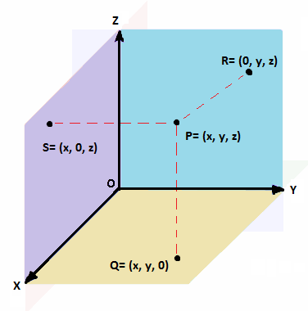
Note that this is the standard placement of the axes. The axes are shown in the positive direction, and extended in the appropriate direction if the negative axes are needed.
The general point P is denoted as (x, y, z) and sits in the general 3D space. If a point lies in the purple region (point S), it is in the xz-plane and has points denoted by (x, 0, z). If a point is in the blue region (point R), it is in the yz-plane and has points denoted by (0, y, z). Building on our previous knowledge of the 2D coordinate system, points in the yellow region (points Q) are in the xy-plane and are now denoted by (x, y, 0). The xz, yz and xy planes are sometimes known as the coordinate planes.

Example 1
Graph x= 2 in ℝ, ℝ², and ℝ³

In ℝ, x= 2 is represented as a point on a line
In, ℝ², x=2 is represented as a line on the graph
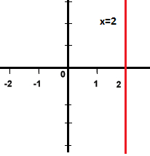

Finally, in ℝ³, x=2 is represented as a plane. This plane extends infinitely in the x, y and z direction.
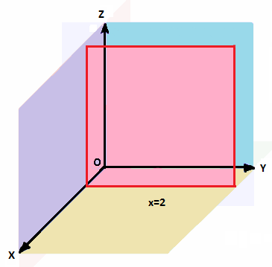

Activity: Graphing the Stars in 3D
Use a sheet of graphing paper. Draw the x, y, and z axes on the graph.
Note- The z-axis is usually a line drawn vertically on the page. Unlike in 2D, the y-axis is horizontal to the page. Finally, the x-axis is drawn diagonally from the origin.
Plot the following stars on a single grid, using 3 dimensional coordinates.
Star | X | Y | Z
Sun | 0.0 | 0.0 | 0.0
Sirius | -3.5 | -3.0 | 7.0
Alpha Centauri | -2.0 | 0.0 | 4.0
Wolf 359 | 4.0 | 4.5 | 5.0
Procyon | -1.0 | 5.5 | -8.0
Tau Ceti | -7.0 | -8.5 | 2.5
Zubenelgenubi | -16.0 | -8.0 | 9.0

Questions
- Which star looks the closest to the Sun? Which star looks the farthest?

- Is this method of graphing more accurate than two-dimensional graphing? Less accurate? Explain your thinking.

- How could you calculate the distance between the stars? Predict a method using your previous knowledge.

