Vector Arithmetic
With the basics of vectors covered, we can now move on to various arithmetic with two or more vectors.

Adding Vectors
When given two vectors <a₁, a₂, a₃> and <b₁, b₂, b₃>, the addition of these two vectors can be expressed by adding its components or in the following formula:
$\vec{a}+\vec{b}=$<a₁+b₁, a₂+ b₂, a₃+ b₃>
Geometrically, this is done by placing the two vectors together head to tail, then drawing the resulting vector. This is occasionally called the parallelogram law, or triangle law.
Steps to visually adding vectors:
Let’s start with two vectors $\vec{a}$ and $\vec{b}$
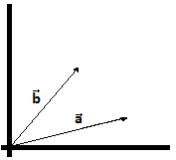
Recall that the arrow end of the vector is called the head, while the other end is called the tail.
To add the two vectors together, vector $\vec{a}$ can be placed head to tail with vector $\vec{b}$ or vector $\vec{b}$ head to tail with vector $\vec{a}$. Note, when re-drawing the vectors, the vectors should be drawn with the same magnitude and direction.
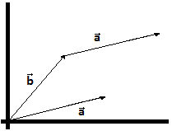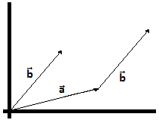
$\vec{b}$ + $\vec{a}$ $\vec{a}$ + $\vec{b}$
Finally, the resulting vector is drawn from the tail of the combined vector to the head.
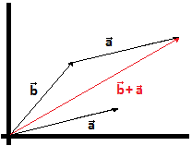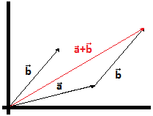
$\vec{b}$ + $\vec{a}$ $\vec{a}$ + $\vec{b}$
Connection to Space
The use of vector addition can explain why space shuttles (such as the EIS orbiter) stay in orbit around Earth. Space shuttles are in free-fall (due to Earth’s gravitational pull), thus producing a downward vector. However if the orbiter is moving in one direction at a certain velocity, the addition of these two vectors produces an angular motion, thus allowing the shuttle to orbit around Earth.
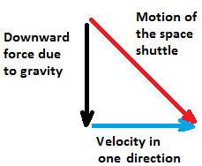
Subtracting vectors:
Subtracting vectors follows a similar formula as the addition method in which the components of one vector are subtracted from the components of another vector.
$\vec{a}-\vec{b}=$<a₁-b₁, a₂- b₂, a₃- b₃>
Visually, there are two ways to look at the subtraction of vectors. The first method is to draw a vector connecting the two heads. Another method, which is more intuitive is to consider the addition of vectors $\vec{a}$ and - $\vec{b}$.
Starting with vectors $\vec{a}$ and $\vec{b}$ once more.
Using method 1, $\vec{a}-\vec{b}$ would look have the following resultant vector:

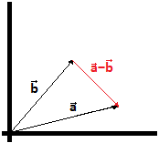
With Method 2 (the addition of vectors $\vec{a}$ and - $\vec{b}$), the result using Method 1 is more intuitive.
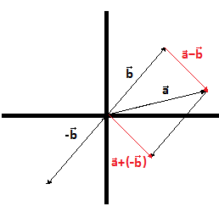
While the two red vectors are in different locations, they have the same magnitude and direction thus making them representations of same vector.
**Important**- Vector addition or subtraction cannot occur unless the two vectors have the same number of components (e.g.: <1, 4, 5> and <2, 4, 6> or <6, 7> and <1, 9>). If the two vectors don’t, addition and subtraction can’t be done (e.g.: <6, 7> and <2, 4, 6>).
Scalar Multiplication:
Scalar multiplication is the stretching or com of a vector by a given value. Vectors can also be flipped through scalar multiplication.
Given a vector $\vec{a}$ =<a₁, a₂, a₃> and a scalar c, the scalar multiplication can be represented by the following equation:
c$\vec{a}$ =<ca₁, ca₂, ca₃>
Where c is multiplied by all the components in vector $\vec{a}$. Geometrically, scalar multiplying a vector will stretch or compress a vector by the scalar value. If c is a negative value, then the scalar will be flipped.
For example, lets looks at vectors $\vec{a}$, 2$\vec{a}$, and -2$\vec{a}$
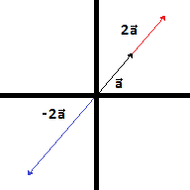
From the example, we can see that the location of the vector does not change. Only magnitude and direction are affected by scalar multiplication.
When c is greater than one, c will be stretched but the direction will not change
When c is less than one, c will be compressed but the direction will not change
When c is less than zero (or a negative value), the vector will point in the opposite direction and will stretch or compress based on the numeric value of c
Now that the basic operations with vectors have been covered, we can move onto properties using these basic operations.
In the 2D plane, parallel lines were lines with the same slope. With vectors, two vectors are considered parallel if there exists a c such that
$\vec{a}$ = c$\vec{b}$
For example, <1, 2, 3> and <2, 4, 6> are parallel vectors because <2, 4, 6> = 2<1, 2, 3>

Unit vectors can be formed from any vector $\vec{a}$ using the following equation:
$\vec{u}$ = $\vec{a}$
II$\vec{a}$II
The unit vector $\vec{u}$ will point in the same direction as the original vector, and will have a magnitude of 1.
Example: Find a unit vector that points in the same direction as $\vec{a}$=< 2, -3, 5>
First we find the magnitude of the vector.
II$\vec{a}$II= √ 2²+ (-3)²+ 5²
= √4+ 9+ 25
= √38 (Note- when forming unit vectors, leave the magnitude as a root number and not a decimal)
Knowing the magnitude of the vector, we can now use scalar multiplication to compress the vector into a unit vector.
$\vec{u}$= 1/II$\vec{a}$II x $\vec{a}$
= 1/√38 x <2, -3, 5>
= <2/√38, -3/√38, 5/√38 >
The new vector points in the same direction as vector $\vec{a}$ and we can confirm it is a unit vector by calculating its magnitude.

Standard Base Vectors
Recall that the standard base vectors or unit vectors were the following:
$\vec{i}$ = <1, 0, 0> or = <1, 0>
$\vec{j}$= <0, 1, 0> or = <0, 1>
$\vec{k}$= <0, 0, 1>
The importance of standard base vectors was never discussed in the precious activity. Now you are more familiar with vector arithmetic, the importance of these vectors can be explained.
Starting with the vector $\vec{a}$ =<a₁, a₂, a₃>, we can break down the vector into the following:
$\vec{a}$ =<a₁, a₂, a₃>
Using vector addition, we can break the vector into three separate vectors.
$\vec{a}$ =<a₁, 0, 0>+ <0, a₂, 0> + <0, 0, a₃>
Using scalar multiplication, the vector can be further broken down.
$\vec{a}$ = a₁<1, 0, 0>+ a₂<0, 1, 0> + a₃<0, 0, 1>
Notice that each of the three vectors formed a simply a scalar multiplication of the standard base vectors. Thus, using the definition of the standard base vectors, we have the following.
$\vec{a}$ =a₁ $\vec{i}$+ a₂$\vec{j}$ + a₃$\vec{k}$
This means that any vector can be written in terms of the standard base vectors, or
<a₁, a₂, a₃>=a₁ $\vec{i}$+ a₂$\vec{j}$ + a₃$\vec{k}$
These two notations will be used interchangeably in the future.
Summary Table of Properties of Vector Arithmetic:
(Note- these properties are based on properties from standard arithmetic and can be proven by computation)
Given vectors $\vec{n}$, $\vec{m}$, and $\vec{v}$ along with two numbers c and a:
- $\vec{n}$+ $\vec{m}$ = $\vec{m}$+ $\vec{n}$
- $\vec{n}$+ $\vec{0}$ = $\vec{n}$
- c ($\vec{n}$+ $\vec{m}$)= c $\vec{n}$+ c$\vec{m}$
- $\vec{n}$+ ($\vec{m}$ + $\vec{v}$)= ( $\vec{n}$+ $\vec{m}$) + $\vec{v}$
- 1$\vec{n}$= $\vec{n}$
- (c+ a)$\vec{n}$= c$\vec{n}$+ a$\vec{n}$

Example
If $\vec{n}$= 4 $\vec{i}$+ 6$\vec{j}$ and $\vec{m}$ = <1, 7, -9>, what is -2$\vec{n}$+3$\vec{m}$?
To solve this question, we simply convert to one notation and do the appropriate arithmetic.
$\vec{n}$= <4, 6 0) so -2$\vec{n}$=<-8, -12, 0>
$\vec{m}$ = <1, 7, -9> so 3$\vec{m}$ = <3, 21, -27>
Therefore, -2$\vec{n}$+3$\vec{m}$= <-8+ 3, -12+ 21, 0+ (-27)>
= <-5, 9, -27>

Practice Problems
- Solve the following vector arithmetic
- <3, -15, 5> + 2<-6, -8, 4>
- The vector <0, 14, -7> multiplied by the number -6
- 4 (<11, -2, -1> + <-13, -19, -7>)
- <5, 9, -8> + (<3, -7, -6> - 2<1, 8, -3>)
- The vector < 10, 2, -4> multiplied by the number -0.5 and added to <7, 3, -1>
- Which of the following vectors are parallel:
- <1, 7, 4>
- <-2, -5, -8>
- <9, 6, 3>
- <4, 10, 16>
- <3, 2, -1>
- <3, 21, 12>
- Given the vector <-6, 12, 4>, determine a unit vector that points in the same direction.
- Given the vector <5, -7, 15>, determine a unit vector that points in the same direction.
- If $\vec{n}$= 7 $\vec{i}$+ 6$\vec{j}$ -3$\vec{k}$ and $\vec{m}$ = <2, 7, -10>, what is 5$\vec{n}$-2$\vec{m}$?
- If $\vec{n}$= 17 $\vec{i}$-4$\vec{j}$ -2$\vec{k}$ and $\vec{m}$ = <1, -8, 0>, what is 4$\vec{n}$-13$\vec{m}$?

