Notes
- Students should be familiar with mapping using the Cartesian plane and calculating the distance between points.
- Students will require access to the list of constellations linked in the introduction
- This activity can be completed individually or in pairs.
- The class can take up the identities of the constellations at the end of the activity

Guess the Constellations (Solutions)
In modern astronomy, a constellation is a group of stars that form a recognizable pattern. Traditionally, it is named after its apparent form, or identified with a mythological figure. While there are millions of stars in the sky, the naked eye can only see a few hundred, which form the constellations. There are 88 officially recognized constellations covering the entire sky.
Plot the points on the grids below. Connect the points as directed and name the constellations!
Constellation 1
Star | Point
Tau Sagittarii | (-10, 0)
Nunki | (-8, 4)
Ascella | (-8,-2)
Nanto | (-5, 4)
Kaus Borealis | (0, 6)
Kaus Media | (3, 2)
Kaus Australis | (3, -4)
Alnasl | (7, 1)
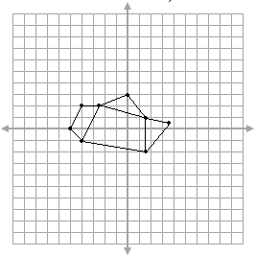
Connect the stars:
- Ascella, Tau Sagittarii, Nunki and Nanto
- Nanto, Kaus Borealis, Kaus Media, Alnasl, Kaus Australis
- Kaus Australi and Ascella
- Nanto and Kaus Media
- Ascella and Nanto
- Kaus Australis and Kaus Media

The constellation is Teapot (part of Sagittarius, the Archer)

Constellation 2
Segin | (--9, 7)
Ruchbah | (-5, -1)
Navi | (0, 0)
Schedar | (4, -5)
Caph | (10, 0)
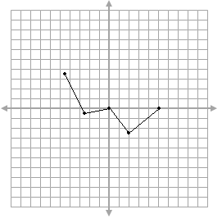
Connect the stars in this order:
- Segin, Ruchbah, Navi, Schedar and Caph
The constellation is Cassiopea

Constellation 3
Alkaid | (-18, 3)
Mizar | (-11, 4)
Alioth | (-6, 3)
Megrez | (1, 1)
Phecda | (3, -5)
Merak | (13, -5)
Dubhe | (15, 3)
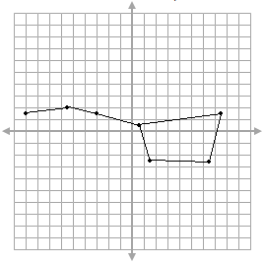
Connect the stars in this order:
Alkaid, Mizar, Alioth, Megrez, Dubhe, Merak, Phecda, Megrez

The constellation is The Big Dipper

Constellation 4
Denebola | (-18, -6)
Zosma | (-11, 0)
Chertan | (-9, -5)
Adhafera | (1, 4)
Algieba | (2, 2)
Al Jabhah | (4, 0)
Rasalas | (4, 8)
Ras Elased | (6, 7)
Regulus | (6, -5)
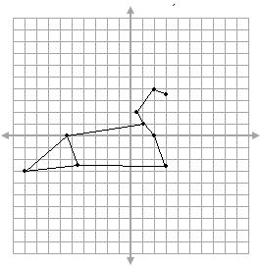
Connect the following stars:
- Denebola, Zosma, Algeiba, Al Jabhah, Regulus, Chertan, and Denebola
- Chertan and Zosma
- Algieba, Adhafera, Rasalas and Ras Elased
The constellation is Leo (the lion)

Calculating Distances between Stars (Solutions)
When graphing the stars on the Cartesian plane, the distance between stars may seem small. In reality, these stars can be lightyears away from each other!
In this problem, the distances between the stars will be calculated using the distance formula used in Cartesian coordinates. These distances will be given in lightyears and the distance formula is given by the Pythagorean Theorem as:
Where the x and y values are given by two points on the plane.

Star | X | Y | Distance from Alkaid | Distance from Megrez
Alkaid | -18.0 | 3.0 | 0.0 | 19.11
Mizar | -11.0 | 4.0 | 7.07 | 12.36
Alioth | -6.0 | 3.0 | 12.00 | 7.28
Megrez | 1.0 | 1.0 | 19.11 | 0.0
Phecda | 3.0 | -5.0 | 22.47 | 6.33
Merak | 13.0 | -5.0 | 32.02 | 13.42
Dubhe | 15.0 | 3.0 | 33.00 | 14.14

- What are the distances of the stars in the constellation from the star Alkaid? Round to two significant figures. Which star is closest to Alkaid?
- Refer to the table for values
- The closest star is Mizar

- If problem one used the star Megrez instead of Alkaid, how far would the stars be? Which star is closest to Megrez?
- Refer to the table for values
- The closest star is Phecda

- Over the years, astronomers notice that Alkaid has moved to (-8, 2). How far is Alkaid from the other stars now? Which star is closest to Alkaid?
- The closest star to Alkaid would be Alioth instead of Mizar
- The new distances would be 0.00, 3.16, 2.24, 9.06, 13.04, 22.14 and 23.02

