Review of concepts
Before starting ‘Introduction to vectors’, it is important to review a few important concepts. The concepts that will be covered are arithmetic, graphing, and calculating distance/length between points.

Solve the following:

- 3+ (-2)= 1
- √121= 11
- (2-√4)/7= 0
- -4-(-6) = 2
- √-16= No solution/4i
- √ (-12)(-3)= 6
- (3x2)- (-4)= 10
- (2x3x√100)/50= 6/5 or 1.2
- 4(x + 3)= 4x + 12
- (3+5)y= 8y

For the function y= x²- x+ 3, fill in the following table:
X | -3 | -2 | -1 | 0 | 1 | 2 | 3
Y | 15 | 9 | 5 | 3 | 3 | 5 | 9

For the function y= 2x²+ x-4, fill in the following table:
X | -3 | -2 | -1 | 0 | 1 | 2 | 3
Y | 11 | 2 | -3 | -4 | -1 | 6 | 17

Graphing points in 2D and 3D
When graphing coordinates, remember that they are generally represented in the form (x, y) in 2D and (x, y, z) in 3D. In the 2D- coordinate plane, the x-axis runs horizontally while the y-axis runs vertically. In the 3D- coordinate plane, the y-axis runs horizontally instead while the x-axis runs forwards and backwards (as if through the page). The z-axis runs vertically instead of the y-axis in the 3D coordinate plane.
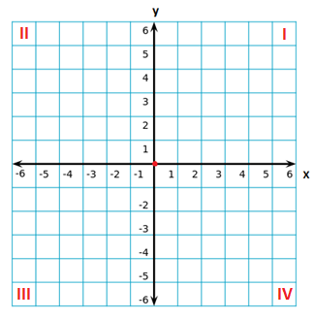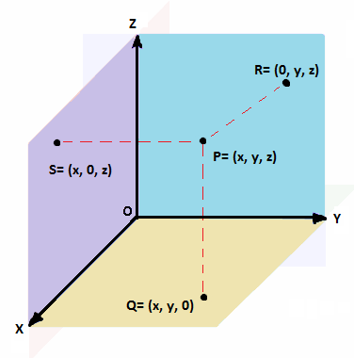
Note that in the 2D coordinate plane, quadrants are numbered in a counter-clockwise manner using roman numerals. Like the 2D coordinate plane, the 3D coordinate plane extends in a positive and negative direction. On the diagram, the four types of points have been graphed.
To calculate the distance between points in the 2D coordinate system and 3D coordinate system two similar equations are used that are based on the Pythagorean Theorem.
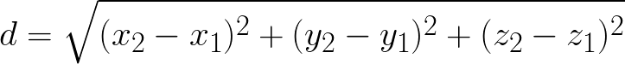
In the 2D coordinate plane, this equation is also used to determine the length of a line given the points at the start and end of the line.

Exercises:
Using the tables of values formed in the previous questions, graph the functions y= x²- x+ 3 and y= 2x²+ x- 4.
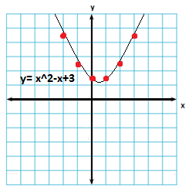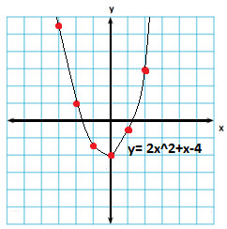

Graph the following points on the appropriate coordinate plane. Two planes (one 2D and one 3D) can be used, however please remember to label the points.

A (2, -4)
B (-3, 5, -2)
C (5, 2)
D (4, 3, 6)
E (-6, -3)
F (0, 0, 2)
G (1, 6)
H (0, 4, 5)
I (0, -2)
J (1, 0, -6)

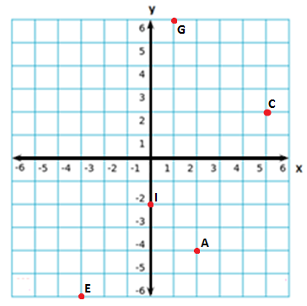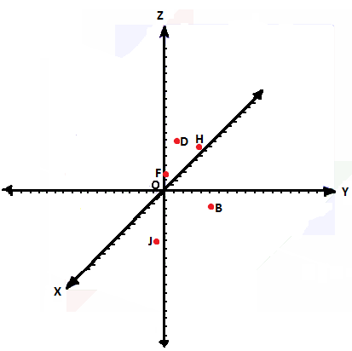
Complete the charts below using the appropriate distance formulas.
Point | X | Y | Distance from A
A | 0 | 4 | 0
B | 4 | 2 | 4.47
C | -12 | -9 | 17.69
D | 6 | -3 | 9.22
E | 15 | 7 | 15.30

Point | X | Y | Z | Distance from C
A | 10 | 12 | -6 | 27
B | -5 | 3 | 9 | 25.34
C | 3 | -14 | -8 | 0
D | 6 | -4 | 15 | 25.26
E | -7 | 18 | 19 | 43.05

