Review: Graphing Coordinates and Calculating Distances between Points
Before you start the activity, let’s review the basics of graphing coordinates on a two-dimensional plane and calculating distances between those points.
Recall that the two dimensional plane has axis x and y. Generally, the x-axis runs from the left to right side of the page while the y-axis runs up and down the page. Points are denoted by (x, y).
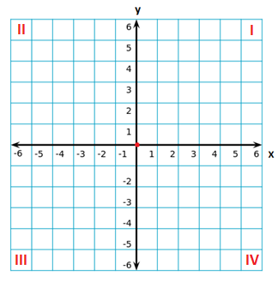
Quadrant I- The values on the x and y-axis are both positive
Quadrant II- The values on the x-axis are negative but the y-values are positive
Quadrant III- The values on the x and y-axis are both negative
Quadrant IV- The values on the x-axis are positive but the y-values are negative
Note that the red point located at (0, 0) is called the origin.
When graphing a point, remember to follow the notation (x, y). This means that the first value represents the point on the x-axis. The second value represents the point on the y-axis. Quadrants are generally discussed using standard notation, or Q followed by the roman number (I, II, III or IV).

Example 1
Graph the point (-2, 3) and the lines y= 5 and x= -3. In what quadrant does the point lie?
The point (-2, 3) has an x-value of -2 and a y-value of 3. This puts the point in the second quadrant. The line y= 5 refers to the set of points that have a y-value of 5, but the x-values may vary. Therefore, we draw a horizontal line where y= 5. For the line x=-3, we draw a vertical line where x=-3 as the y-values may vary, but the x-value will strictly be -3.
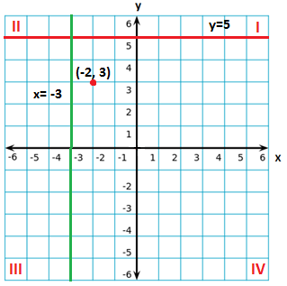

Guess the Constellations
In modern astronomy, a constellation is a group of stars that form a recognizable pattern. Traditionally, it is named after its apparent form, or identified with a mythological figure. While there are millions of stars in the sky, the naked eye can only see a few hundred, which form the constellations. There are 88 officially recognized constellations covering the entire sky.
Plot the points on the grids below. Connect the points as directed and name the constellations using the link “The 88 constellations” on the course page.
Constellation 1
Star | Point
Tau Sagittarii | (-10, 0)
Nunki | (-8, 4)
Ascella | (-8,-2)
Nanto | (-5, 4)
Kaus Borealis | (0, 6)
Kaus Media | (3, 2)
Kaus Australis | (3, -4)
Alnasl | (7, 1)
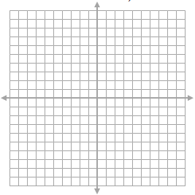
Connect the stars:
- Ascella, Tau Sagittarii, Nunki and Nanto
- Nanto, Kaus Borealis, Kaus Media, Alnasl and Kaus Australis
- Kaus Media and Ascella
- Nanto and Kaus Media
- Ascella and Nanto
- Kaus Australis and Kaus Media

The constellation is _________________________________

Constellation 2
Segin | (--9, 7)
Ruchbah | (-5, -1)
Navi | (0, 0)
Schedar | (4, -5)
Caph | (10, 0)
Connect the stars in this order:
- Segin, Ruchbah, Navi, Schedar and Caph
The constellation is _________________________________

Constellation 3
Alkaid | (-18, 3)
Mizar | (-11, 4)
Alioth | (-6, 3)
Megrez | (1, 1)
Phecda | (3, -5)
Merak | (13, -5)
Dubhe | (15, 3)
Connect the stars in this order:
Alkaid, Mizar, Alioth, Megrez, Dubhe, Merak, Phecda, Megrez

The constellation is _________________________________

Constellation 4
Denebola | (-18, -6)
Zosma | (-11, 0)
Chertan | (-9, -5)
Adhafera | (1, 4)
Algieba | (2, 2)
Al Jabhah | (4, 0)
Rasalas | (4, 8)
Ras Elased | (6, 7)
Regulus | (6, -5)
Connect the following stars:
- Denebola, Zosma, Algeiba, Al Jabhah, Regulus, Chertan, and Denebola
- Chertan and Zosma
- Algieba, Adhafera, Rasalas and Ras Elased
The constellation is _________________________________

Calculating Distances between Stars
When graphing the stars on the Cartesian plane, the distance between stars may seem small. In reality, these stars can be lightyears away from each other!
In this problem, the distances between the stars will be calculated using the distance formula used in Cartesian coordinates. These distances will be given in lightyears and the distance formula is given by the Pythagorean Theorem as:
Where the x and y values are given by two points on the plane.
When using this equation, it is important to choose which point will be point 1 and which will be point 2. This way, the x and y-values will not be switched and cause errors in your calculations.
Example 2
Calculate the distance between the stars Zosma and Chertan, located at (-11, 0) and (-9, -5) respectively.
To calculate the distance, first decide which star will be point 1 and point 2. In this example, Zosma (-11, 0) will be point 1 and Chertan (-9, -5) will be point 2. With these designations, we use the equation to calculate the distance between the points.
_____________
d= √ [-9-(-11)]²+ (-5-0)²
= √ (2)²+ (-5)²
= √ 4+25
= √ 29
= 5.39

Calculating Distances between Stars
The chart below lists the coordinates of the stars in mystery constellation 3. Use the chart to complete the following questions.
Star | X | Y | Distance from Alkaid | Distance from Megrez
Alkaid | -18.0 | 3.0 | 0.0
Mizar | -11.0 | 4.0
Alioth | -6.0 | 3.0
Megrez | 1.0 | 1.0 |  | 0.0
Phecda | 3.0 | -5.0
Merak | 13.0 | -5.0
Dubhe | 15.0 | 3.0

- What are the distances of the stars in the constellation from the star Alkaid? Round to two significant figures. Which star is closest to Alkaid?

- If problem one used the star Megrez instead of Alkaid, how far would the stars be? Which star is closest to Megrez?

- Over the years, astronomers notice that Alkaid has moved to (-8, 2). How far is Alkaid from the other stars now? Which star is closest to Alkaid?

